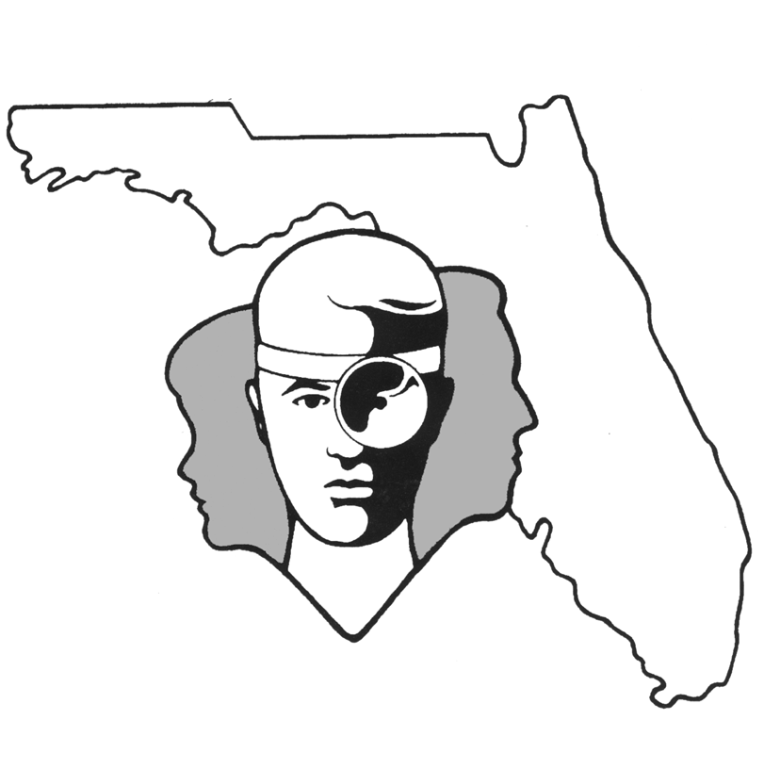
TALLAHASSEE EAR, NOSE & THROAT - HEAD & NECK SURGERY, P.A.

www.TallyENT.com Office Phone: 850-877-0101

PATIENT DISCHARGE INSTRUCTIONS: THYROIDECTOMY and/or PARATHYROIDECTOMY
POST-ANESTHETIC CONSIDERATIONS: Anesthetics and other medications will be in your body 24 hours, so you may feel a little sleepy. This feeling will slowly wear off but, for the next 24 hours adults should not::
- Drive a car, operate machinery or power tools ● Drink any alcoholic beverages
- Take any medication except as directed ● Make any important decisions – such as signing legal documents
Certain anesthetics and pain medications may produce nausea & vomiting which usually resolves by the evening of the surgery.
ACTIVITY: Use common sense in terms of the amount of activity you do. You can gradually increase activity after the procedure, but keep it light for 2 weeks.
DIET: Progress slowly to a regular diet as tolerated. It is better to start with liquids such as Ginger Ale or apple juice, then soup and crackers, and gradually solid foods.
THYROID SURGERY: If you have had a Total Thyroidectomy, your special consideration is to be aware that your blood calcium level may drop. If you have a tingling sensation or numbness around your lips or fingers, feel “weak” more than otherwise would be expected, or are having unexplained muscle cramps - please call and discuss this with physician. These symptoms may occur even up to 5-7 days after surgery.
WOUND CARE: It is not uncommon to have steri-strips and a gauze dressing over the incision site. You may remove the dressing the day after the procedure or change it sooner should it become soaked with blood. Dr. Becker’s patients should follow her specific directions for wound care. Other than cleaning, please leave the sutures or staples alone. If the edges of the steri-strips become soiled or curl up you may trim them – do not remove them. All of these items should be removed only in the office at your follow up visit. Beginning the day after the surgery, you can clean the incision with peroxide and a Q-Tip or mild soap and water. If you do not have steri strip tape, apply antibiotic ointment three to four times a day. You will find this is easier as each day passes. We would like for you to keep the wound dry for 12-48 hours.
MEDICATIONS: In general, you will probably have a prescription for a pain medication and, in a few cases, an antibiotic. Any antibiotic should be taken as prescribed for as many days as your surgeon has recommended. Use only Tylenol or other pain medication prescribed by your surgeon. Do not take aspirin or anti-inflammatory products (these include Motrin, Advil, Ibuprofen, Aleve, etc.), or any pain medication other than that prescribed by your surgeon. This is very important as some of these medications can cause bleeding. If you have had your entire thyroid removed, you will need to be on some type of replacement medication.
SYMPTOMS TO EXPECT: You can expect moderate discomfort the first night. This should improve each day. There may be a mild fever, but generally not above 101.5 degrees after the first night. There will be a mild bit of swelling during the first 24-36 hours. You may have a mild sore throat from the general anesthetic. There may be a mild bit of bloody oozing during the first night, but this generally resolves after 12 hours.
WHEN TO CALL YOUR PHYSICIAN:
- If there is increasing pain, redness, or swelling around your incision (signs of infection) after the first 2-3 days
- Numbness or tingling of the lips or fingers
- Muscle cramping or seizures
- A temperature of more than 101.5 degrees at any point
- Difficulty breathing
- Increased neck swelling
SPECIAL INSTRUCTIONS: A postoperative appointment has already been scheduled. Please refer to your Surgery Information Sheet or call the office to confirm the appointment date and time. We strongly suggest that a responsible adult be with the surgical patient the rest of the day and also during the night for the surgical patient's protection and safety. Please contact your physician immediately if you have an emergent situation. If you find that you cannot contact them, but feel that your signs and symptoms warrant a physician's attention, go to the nearest emergency room. For non-emergent questions (i.e. appointments or general questions), please call during normal office hours.

